Visual form of my technical problem running code of Farrant and Peersman(2006), "Is the Exchange Rate a Shock Absorber or a Source of Shocks? New Empirical Evidence", JMCB, vol 38, no. 4, pp 939-961.

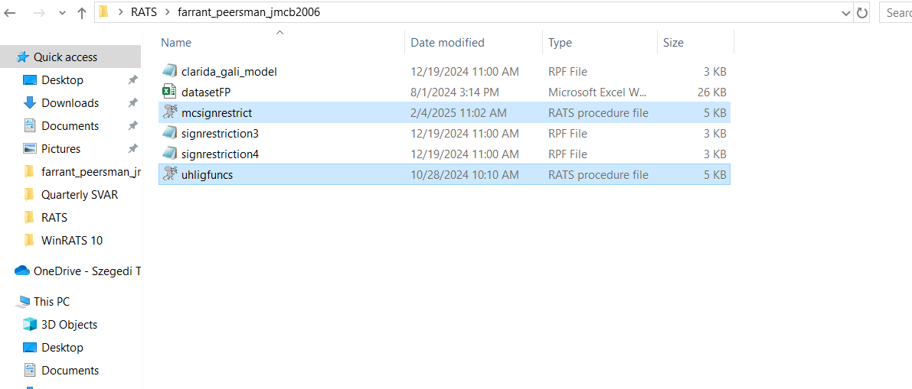
- I copied mcsignrestrict and uhligfuncs files and pasted inside the folder of the paper.

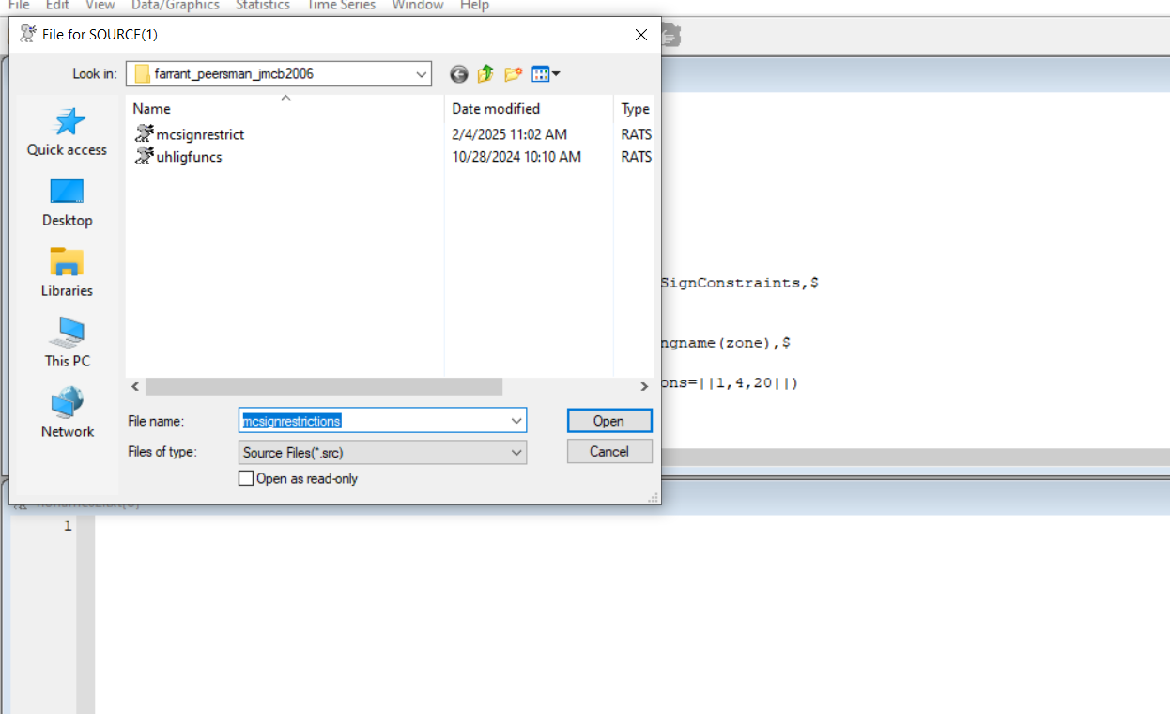
- I opened signrestriction4 file in RATS, then highlighted all then pressed run button then a new window popped up as in the picture.

- Then I chose file mcsignrestrict and pressed open, the following window appeared:
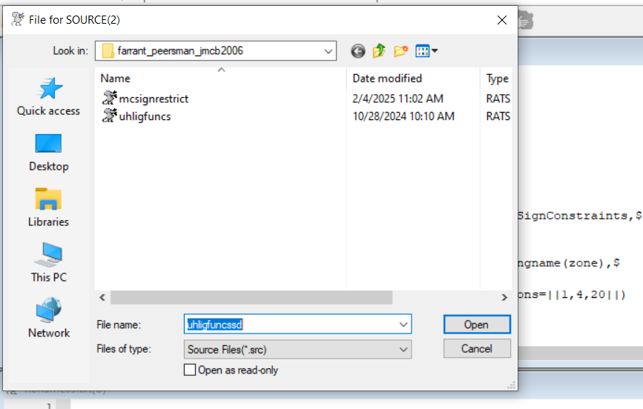

Since I could not find uhligfuncssd, I chose uhligfuncs ( I am sure whether they are similar or not). Afterthat, the following error message came.

## SX11. Identifier UHLIGACCEPTSD is Not Recognizable. Incorrect Option Field or Parameter Order?
>>>> if UhligAcceptSD(<<<<
Is it possible you meant
UHLIGACCEPT
If the name isn't mistyped, it's possible that you have a poorly formatted instruction
Common errors are
* a space before the ( in an option field
* a missing space before = in a SET or FRML
* a missing $ at the end of a long line which continues to the next

Please advise me how to solve this problem step by step since I am a new user of RATS.

