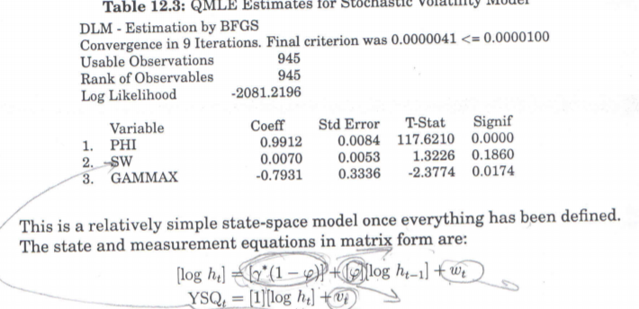
And I have this form as log $h_{t}=Inσ_{t}^{2}$
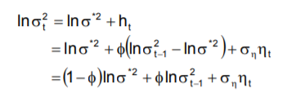

- $γ^{*}(1-φ)$ symbolizes GAMMAX and also $\left(1-Φ\right)Inσ^{*2}$ in my equation.

- $φ$ symbolizes PHI and also $\left(Φ\right)$ in my equation.

- SW symbolizes $w_{t}$ or $v_{t}$ ? and İn my equation it is symbolizes $σ_{η}$ or $η_{t}$ .

