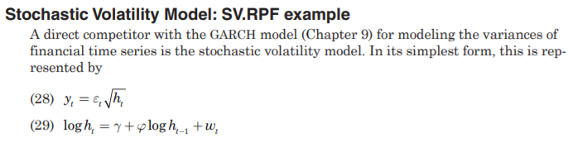
I want to add one variable (X₁) to the equation(28) but I can not be sure how I should do that.
(28) y_{t}=x₁+$ε_{t}\sqrt{h_{t}}$
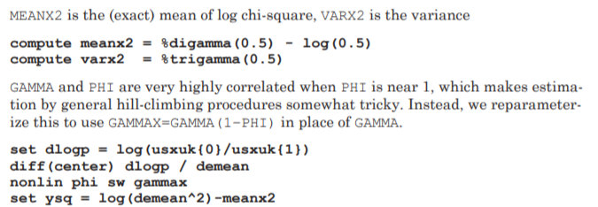
Using above model
dec vect[series] w(2)
set dlogp = log(Y/Y{1})
diff(center) dlogp / demean
set w(1) = log(demean**2)-meanx2
set dlogp = log(X/X{1})
diff(center) dlogp / demean
set w(2) = log(demean**2)-meanx2
nonlin w(2) phi sw gammax
set ysq = log(demean**2)-meanx2
OR
set dlogp = log(Y{0}/Y{1})
diff(center) dlogp / demean
nonlin X₁ phi sw gammax
set ysq = log(demean**2)-meanx2
AND THEN
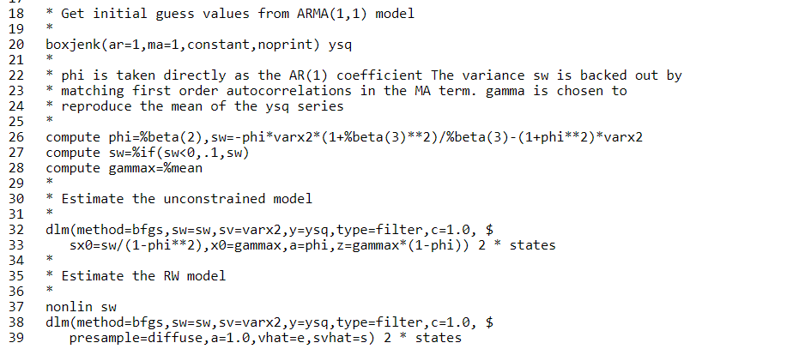
Should I add X variable to the somewhere above?

